**Forest Methodist Church**

**September Newsletter**

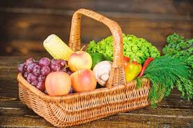

**Serve Learn Share Praise**

Methodist Church C:\Users\Bryan Guille\Pictures\Church\orb-and-cross-0712.jpg

Bailiwick of Guernsey

**Minister:**

**Rev’d Jacky Cottrell**

**The Manse, 2, Le Chene D’Mont, Le Chene,**

**Forest, GY8 0AL Tel: 234105**

**Email:** [**revdcottrell@gmail.co**](mailto:revdcottrell@gmail.co)

Dear friends,

I hope you enjoy the last remains of the summer sunny days. Summer for me has been full of visitors. It has been wonderful to share this beautiful island with family and friends. In church we too have had visitors arriving, I have heard back what a warm welcome, they happily received. To be welcoming is a Christian imperative Hebrews 13:1-2 tells us ‘Let mutual affection continue. Do not neglect to show hospitality to strangers, for by doing that some have entertained angels without knowing it.’

At the manse as I welcomed friends and family, we also had Pickles visit my daughter’s dog, more a monkey than an angel I think, rather mischievous, loves attention. Still he enjoyed the beaches and a good run around and is very much part of their family. Having so much time around my grandchildren, 5yr and 7yr olds was a joy! Children do see life differently. I could listen for ages to their never ending conversations. Really watching and listening to children I think helps us to understand Luke 18:15-17, ‘People were bringing even infants to him that he might touch them, and when the disciples saw it, they sternly ordered them not to do it. But Jesus called for them and said, “Let the children come to me, and do not stop them, for it is to such as these that the kingdom of God belongs. Truly I tell you, whoever does not receive the kingdom of God as a little child will never enter it.”

One morning the youngest was still tired and a little grumpy, he was dragging his feet to get ready and bickering with his sister. As he was reluctantly bundled in his car seat, I thought perhaps if I made him laugh, he might snap out of it. So I put the sun cream on my face as normal, but I did not rub it in. So I went out to him and asked him if I had any cream left on my face, he grumpily looked and shook his head, not in the least amused as I had expected. As I turned away, he mumbled, ‘Grandma’ and on turning back he said in a whisper I did still have cream on my face! I was so touched that even in a mood, his kindness shone through and he did not want me to look foolish. Children teach us much, watching the enthusiasm light up their faces at the insignificant things, new pen, bargain from charity shop. Also how they delight on noticing the little things of nature, a butterfly on the bush, a cricket chirping, flower growing in the crack of the road. We can learn much of Gods kingdom on earth through youngsters. I pray you have been blessed by the young in your life.

Big Blessings, Rev Jacky

**Knitting and Church family**

**We’re a loose-knit family;**

**Mostly knit with a few pearls.**

**We have our Castings on and Castings off.**

**We are open-weave, spinners of yarns,**

**Embroiderers of the Truth.**

**We pull strings for good causes.**

**Unkindness needles us.**

**We’re granny and reef knots.**

**Occasionally we drop a stitch**

**but we keep to the pattern**

**and we never pass a slipped stitch over.**

**By Sharyn Owen**

**Soup and Cake Lunch**

**Saturday 20th September 12 – 2pm**

At Forest Methodist Church

**St. Paul's Methodist Church**

are commemorating 200 years of being a Methodist Church,

 over the weekend of 13th and 14th September 2025.

**Saturday, 13th September**

Exhibition of the history 1.00 -3.00 p.m. refreshments available

Concert 3.30 -4.45 p.m.

State of Harmony, Saxophonix and Singing from the Heart

**Sunday, 14th September**

A service of Celebration 10.30 a.m.

ALL ARE WELCOME

**Welcome Service**

**31st August 4.00PM at Les Camps**

for Rev Anne Richardson

(No evening service at Forest)

**CONCERT AT CAPELLES METHODIST CHURCH**

**On Friday 19th September at 7.30**

Given by GU10

Free entry and refreshments will be served during the interval

Kind donations for the Tumaini Fund much appreciated

**CIRCUIT ALPHA 2025**  
  
A warm welcome to come and join in this Alpha Course  
Starting **Wednesday 1st October, 6.30pm** at Forest Methodist

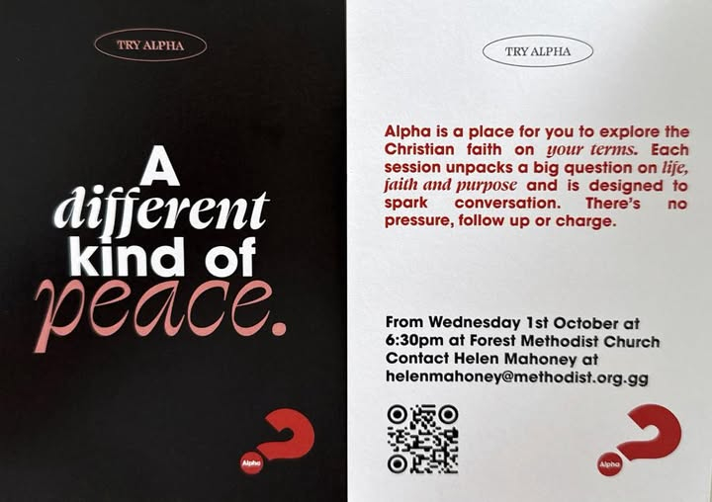

**Preaching & Duty Stewart Schedule**

God & Marmalade is at 8.45am

|  |  |  |
| --- | --- | --- |
| Date | AM Preacher | Duty Steward |
| **7th September** | Jacky Cottrell | Sarah |
| **14th September** | 11am Jacky Cottrell | Carole |
| **21st September** | Fellowship | Nev |
| **28th September** | Jacky Cottrell (HC) | Rosemary |

Evening Service is at 6pm

|  |  |  |
| --- | --- | --- |
| Date | PM Preacher | Duty Steward |
| **7th September** | Jacky Cottrell | Beth |
| **14th September** | N/A | N/A |
| **21st September** | Anne Richardson | Pam |
| **28th September** | Jacky Cottrell (HC) | Nev |

**Flower Rota**

|  |  |
| --- | --- |
| Date |  |
| 7th | Anne Le Marchant |
| 14th | Jenny Falla (Harvest) |
| 21st | Rosemary Willey |
| 28th | Debbie Dorey |

**G & M Breakfast Rota**

|  |  |  |  |
| --- | --- | --- | --- |
| **Date** | **Breakfast** | **Setting Up** | **Cloth Wash** |
| **7th September** | Sandra/Ian  Jenny | Carole/Nev | Margaret |
| **14th September** | Catering (Harvest) | David (237669) | Sarah |
| **21st September** | Sandra/Ian  Jenny | Michelle G | Jenny |
| **28th September** | Carole/Nev | Steve/Jan (07911 734700) | Beth |

Welcome Steward Rota

|  |  |  |
| --- | --- | --- |
| **DATE** | **AM** | **PM** |
| **7th September** | Beth | Sarah |
| **14th September** | Andrea | N/A |
| **21st September** | Jenny | Brian |
| **28th September** | Andrea | Beth |

**With grateful thanks to all who give their time to the service of the church**

**☼**

Notices/articles for next month let Michelle know by **Fri 26th September**

Tel no: 01481 266019/07781 166019

email: [mgilson_gsy@hotmail.com](mailto:mgilson_gsy@hotmail.com)

**MEET & EAT**

This is a house group which meets usually on the first Monday of each month.    We often meet at different participants homes as and when they can offer to host.  There’s usually between 6 and 10 people that come along to enjoy some food followed by a discussion based on the previous Sunday’s G&M but not exclusively.  We meet at 7pm and finish around 9pm.  There is a minimum donation requested of £5 to cover the cost of catering.

**The next Meet & Eat will be Monday 8 September and will be held at Andrea’s house.**

Should you wish to give us a try you can either put your name(s) on the list in the Welcome Area or call Carole on 07781 438265.

**FOREST LADIES GROUP.**

A very warm welcome to any lady who would  
Like to join us this month when we have on  
  
**Thursday 11th September, 2.00pm**  
A talk on the work of the Citizens Advice  
  
    And on  
  
**Thursday 25th September 12.30pm**  
Lunch at the Longfrie  
  
Further details from Beth Tel: 07781 163564

**HARVEST CELEBRATIONS**  
  
**Theme this year**

**' HOME IS WHERE THE HEART IS'**

On **Saturday 13th September from 9.30am** we will be decorating the Church  
If you can spare some time to help decorate and/or bring items this would be much appreciated.  
  
**Sunday 14th September at 11.00am.**  
Harvest Thanksgiving Service led by Rev Jacky  
Followed by Lunch at 12.00pm  
No evening service  
  
Gifts for the Guernsey Welfare Foodbank most welcome



**Prayer Pages**

**IN YOUR PRAYERS**  
If you know of someone who would appreciate being on our prayer list, please ensure you have the person's permission before passing their name to Michelle.

Please pray for Ron Gould, Win De La Mare, Karen Harrison,

Rachel Meinke, Caroline Treharne, Joyce Baudains,

Margaret Boden-Heaume, Bob Cartmell,

Rev John Luff and his wife Carole,

Howard Ellis (Sandra’s son), Debbie Hobbs,

Colleen Ogier and Debbie Dorey,

Sarah’s grandson Edward

and Carole’s friend Coral.

**Bailiwick of Guernsey Churches Prayer Cycle for 2025**

Sept 01 ***(World day of prayer for the care of creation)***

Sep 07 Ecumenical ministry to men and ladies’ breakfasts at Les Cotils Christian Centre

Sep 14 PACE / Catholic schools in Guernsey ***(Education Sunday)***

Sep 21 ***INTERNATIONAL DAY OF PEACE*** Sep 21 Delancey Elim church / Parish church of St Michel du Valle (Vale Church)

22-05 Oct ***FAIRTRADE FORTNIGHT***

Sep 28 Alderney: Parish church of St Anne / St Ann & St Mary Magdalen Catholic Church / Methodist church

## 

## FACTOR 7

**Please pray wherever you are: at home, work, in your car or shower, pray for**

7 minutes at 7am and/or 7pm

FOCUS THIS MONTH

Pray at this time of new starts and returns to education, for all teachers, learners and support staff.  Pray for the Holy Spirit to give strength, encouragement and inspiration for all.

As we celebrate harvest, let us give thanks for our many blessings. Please pray for Guernsey Welfare and for those who will receive our harvest gifts.

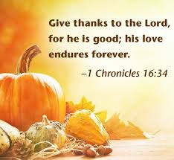

A priest, a minister, and a rabbi want to see who’s best at his job. So, they each go into the woods, find a bear, and attempt to convert it.

Later they get together.

The priest begins: "When I found the bear, I read to him from the Catechism and sprinkled him with holy water. Next week is his First Communion."  
"I found a bear by the stream," says the minister, "and preached God’s Holy Word. The bear was so mesmerized that he let me baptise him."  
They both look down at the rabbi, who is lying on a gurney in a body cast.

"Looking back," he says, "maybe I shouldn’t have started with the circumcision."

